Lakadong Turmeric – The Golden Gem of India with 9% Curcumin
Meta Description: Discover Lakadong Turmeric – India’s premium 9% curcumin variety exported by The Export Express. Known for its golden color, purity, and powerful health benefits.

🌿 Introduction: India’s Golden Legacy in Every Root
India has long been celebrated as the land of turmeric, the “golden spice” revered in Ayurveda, cuisine, and wellness traditions for over 4,000 years. Among its many varieties, Lakadong Turmeric from Meghalaya stands apart as the most potent and premium — naturally rich in curcumin (up to 9%), the bioactive compound behind turmeric’s color, flavor, and healing properties.
At The Export Express, we proudly source and export Lakadong Single-Polished Turmeric Fingers — carefully sun-dried and processed to retain maximum aroma, purity, and nutritional value.
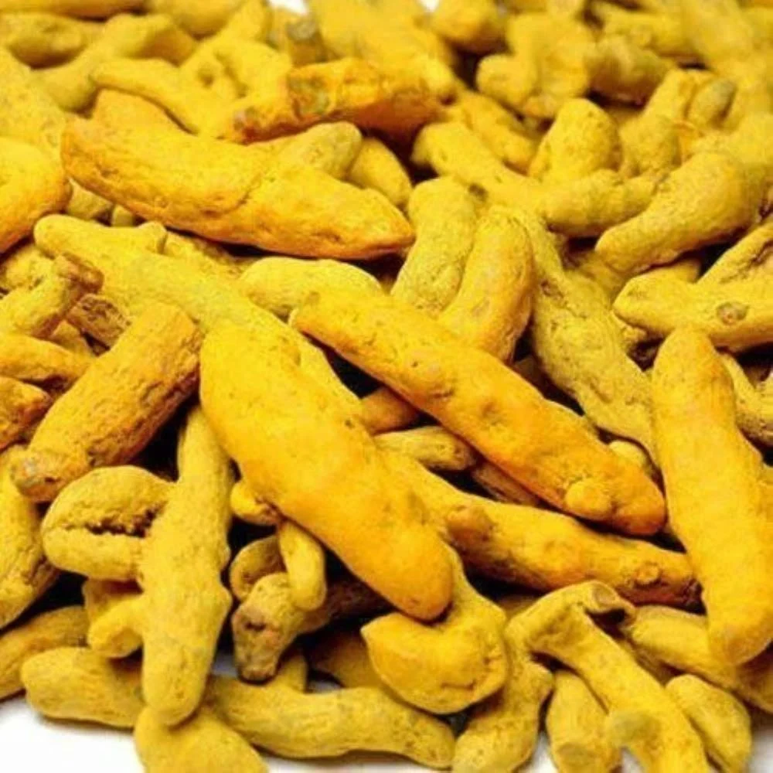
Caption: Premium Lakadong turmeric roots – golden in color, rich in curcumin, and grown in the pristine hills of Meghalaya.

🧾 Product Specifications
Attribute | Specification
Variety | Lakadong
Curcumin Content | 9%
Polish Type | Single Polished
Form | Finger
Length | 2.5 inch
Color | Bright Yellow
Shelf Life | 12 Months
Moisture | 2–3%
Purity | 98%
Botanical Name | Curcuma longa
Country of Origin | India
Packaging Type | PP Bag
Packaging Size | 25 kg
Storage | Store in cool, dry place
Availability | In Stock

🌱 Authenticity and Cultivation
Lakadong Turmeric is grown organically in the Jaintia Hills of Meghalaya, where the unique soil composition and high altitude give rise to its unmatched curcumin concentration and natural aroma.
Farmers here use traditional, chemical-free methods, relying on rich red loam soil and pure rainfall irrigation. The fingers are harvested by hand, cleaned, boiled, sun-dried, and single-polished — maintaining their authenticity and nutritional integrity.

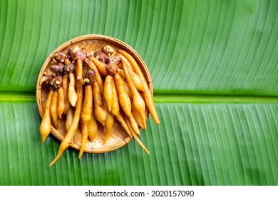
Caption: Naturally sun-dried Lakadong fingers – retaining their golden hue and essential oils for superior potency.

💛 Key Features of The Export Express Lakadong Turmeric
- Premium Variety: Lakadong turmeric is globally recognized for its exceptionally high curcumin content (up to 9%), making it the most powerful natural anti-inflammatory spice.
- Vibrant Color & Aroma: Its rich yellow tone and earthy fragrance make it perfect for both culinary and medicinal use.
- Natural & Authentic: Harvested and dried without artificial color or chemicals.
- Long Shelf Life: Stays fresh and aromatic up to 12 months when stored properly.
- Sustainably Sourced: Grown using eco-friendly, ethical practices by smallholder farmers.

🩺 Health Benefits of Lakadong Turmeric
Turmeric has been called the “Golden Healer” in Ayurveda — and modern science agrees. Here’s how Lakadong Turmeric contributes to overall wellness:

1. Anti-Inflammatory Powerhouse
Curcumin combats inflammation at the molecular level, helping reduce joint pain, arthritis, and swelling.

2. Rich in Antioxidants
The antioxidants in turmeric protect the body from free radical damage, slow aging, and strengthen immunity.

3. Boosts Immunity
Regular consumption supports the immune response, helping the body resist infections naturally.

4. Promotes Digestive Health
Curcumin aids bile production, enhances digestion, and reduces bloating or indigestion.

5. Supports Liver Detoxification
Acts as a natural cleanser that helps flush toxins and improve liver function.

6. Improves Skin Radiance
Turmeric’s antibacterial and antioxidant qualities help manage acne, reduce scars, and restore glow.

7. Heart and Brain Health
Curcumin supports cardiovascular function, reduces cholesterol oxidation, and promotes better cognitive health.

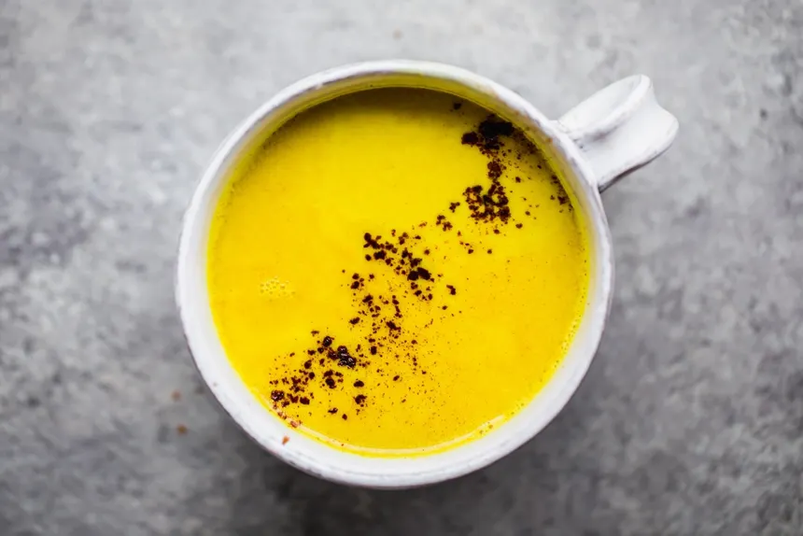
Caption: Golden milk made with Lakadong turmeric – a nourishing drink for immunity and vitality.

🍛 Culinary and Daily Uses
Lakadong turmeric isn’t just a health booster — it’s a vibrant ingredient in global cuisines.

In Indian Kitchens:
- Add ½ tsp to curries, dals, rice, and soups for flavor and color.
- Mix into haldi doodh (turmeric milk) for a soothing bedtime tonic.

In Herbal Teas:
Steep dried turmeric fingers or powder in hot water with ginger and honey for a natural detox tea.

In Supplements & Formulations:
Used in herbal capsules, immunity boosters, and turmeric curcumin extracts for health industries worldwide.

🌿 Ayurveda and Lakadong Turmeric
In Ayurveda, turmeric (Haridra) is classified as “Tridoshic” — balancing Vata, Pitta, and Kapha energies.
It’s often prescribed for:
- Skin purification and wound healing
- Respiratory and digestive disorders
- Blood cleansing and liver strengthening
Lakadong turmeric’s higher curcumin content makes it even more effective in modern nutraceutical and Ayurvedic formulations.

📊 Comparative Insight – Why Lakadong Leads
Variety | Curcumin (%) | Best Use | Origin | Shelf Life
Lakadong | 7–9% | Medicinal, premium export | Meghalaya | 12 months
Alleppey Finger | 5–6% | Culinary, flavoring | Kerala | 24 months
Erode | 3–4% | General spice use | Tamil Nadu | 18 months
Lakadong outshines all others for its potency, purity, and natural color intensity.

🧂 Packaging & Export Options
At The Export Express, we provide customized packaging solutions for both retail and bulk clients.
Packaging Type | Size | Material | Use Case
PP Bag | 25 kg | Industrial-grade | Bulk Export
HDPE Drum | 50 kg | Long shelf life | Pharmaceutical / Extract
Retail Pouches | 250 g – 1 kg | Private Label Available | Consumer Market

🌍 Export and Global Demand
Lakadong turmeric has growing demand in North America, Europe, Japan, and the Middle East for use in:
- Organic food blends
- Herbal teas
- Dietary supplements
- Natural cosmetics
With our GMP-compliant facilities, FSSAI and ISO certifications, and private labeling services, The Export Express is your trusted partner for consistent, high-grade turmeric exports from India.

🏭 Why Choose The Export Express
- Sourced Directly from Farmers: Ensures fair trade and traceable origin.
- Quality Tested: Verified for curcumin %, moisture, and microbial purity.
- Custom Packaging & Branding: OEM and white-label options available.
- Global Export Expertise: Serving distributors and wellness brands across continents.
- In-Stock Year-Round: Stable supply chain and prompt delivery.

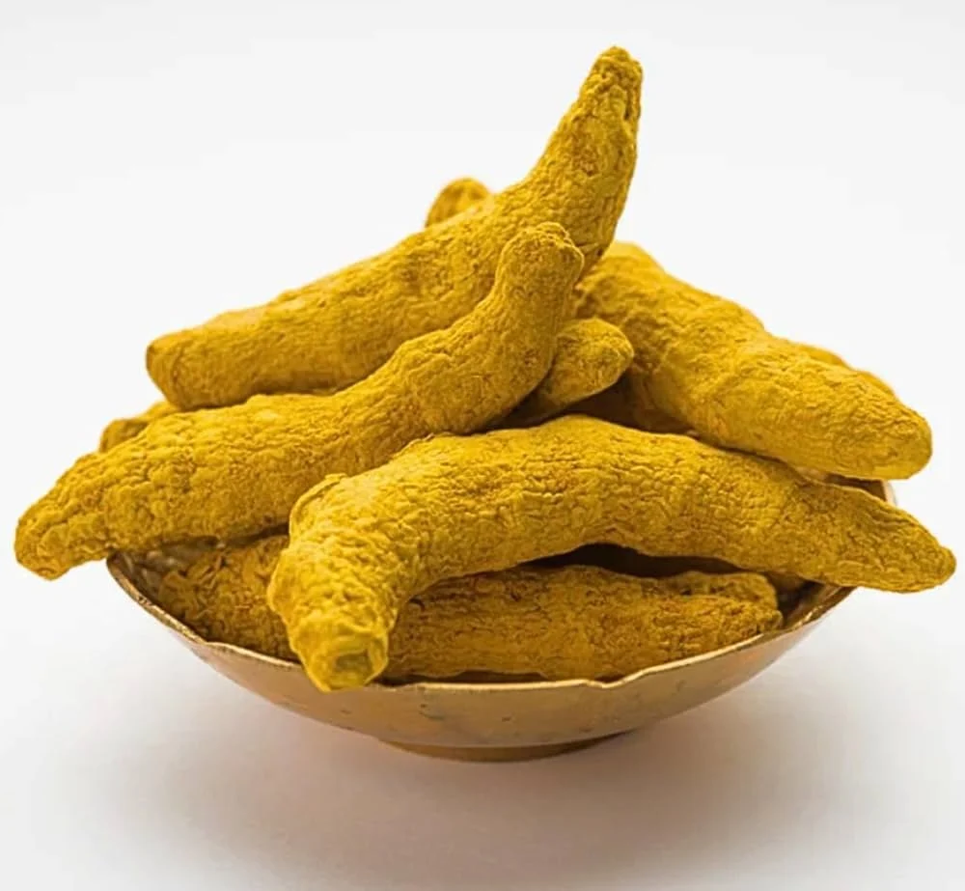
Caption: The Export Express – delivering premium turmeric to global markets with quality assurance and sustainability.

🔗 Suggested Internal Links
- Explore Herbal Exports from India
- Buy Lakadong Turmeric Exports
- Learn About Ayurvedic Ingredients
- Contact for Bulk Orders

🌾 Conclusion: India’s Finest Turmeric for the World
From the misty hills of Meghalaya to markets across the globe, Lakadong Turmeric represents the finest India has to offer — potent, pure, and golden. Its superior curcumin level, authenticity, and sustainable cultivation make it the perfect choice for global buyers seeking unmatched quality.
Partner with The Export Express to source the best turmeric from India — bringing the golden spice of Ayurveda to every corner of the world.

Keywords: Lakadong turmeric, turmeric exporter India, herbal export India, turmeric with 9% curcumin, turmeric finger export, Curcuma longa, The Export Express.

